Project Identification

Project: | Virtual Assistant
Prepared By: | T38
Document Version: | 0.1
Published Date: | 10/4/2021

Contributors

Name | Title
Pruthvi Soni | Technical Reviewer
Saumya Mistry | Software Architect
Namya Patel | Requirement Engineer
Sahay Patel | Project Manager
Vraj Soni | Scrum master

Distribution

Name | Title
Saumya Mistry
Pruthvi Soni
Namya Patel
Sahay Patel
Vraj Soni

Referenced Documents

Version number | Title | Author | Date | Source / Location

Revision History

Version Number | Revision Date | Summary of Changes | Modified by

TABLE OF CONTENTS
1. Business Context Diagram 3
2. REquirements Scope Statements 4
3. High Level Business Requirements (HLR) Traceability 4
4. High Level Business Requirements Sign-Off 5

- Business Context Diagram
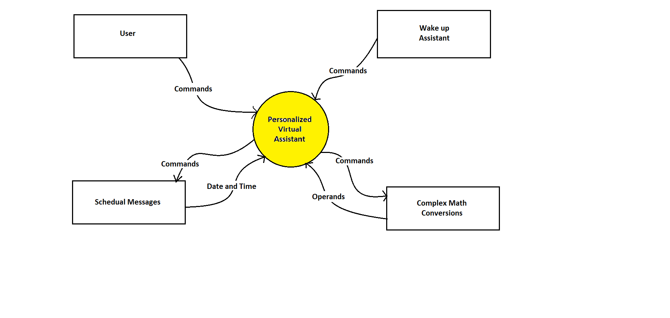
Requirement Scope Area | Description
Personalized Virtual Assistant | Area responsible for providing task outputs which user has asked for.

External Entity | Description
User | User who can give commands to the assistant directly.
Wake up assistant | Whenever user gives a command, assistant will wake up and come in its active state and starts taking commands.
Schedule messages | When assistant is asked to do this task, it will schedule an automated message with the time user wants to send this message.
Complex math conversions | User can ask for any type of mathematical conversion and in output, assistant will convert that into calculated answer.

Information Flows | Description
Commands | It is the commands given by the user to perform any tasks.
Date and Time | When a user wants to schedule a message, Date and Time will be require to setup that message.
Operands | It will be required to perform any complex mathematical conversions.
- Requirements Scope Statements
HLR# | Description | Priority  (H, M, L)
 | All Language Support: Define or clarify construct-irrelevant words, phrases, and sentences using plain language, synonyms, definitions, examples, and consistent language. It must support all the possible languages such as English, Hindi, Spanish, French etc. | H
 | It must perform the basic mathematical operations with the commands. For example,  ● Addition (+)  ● Subtraction (-)  ● Multiplication (*) and  ● Division (/)  These operations are commonly called arithmetic operations. | H
 | Weather forecast: It must include a daily report of meteorological observations, and of probable changes in the weather. When one user asks about weather forecast, assistant will read out loud the predicted weather. | M
HLR04 | Turn on or delete alarms, reminders, or events: It must include commands to set an alarm, important reminders, and events whenever user wants to. A user can also delete or turn off these commands. | L
HLR05 | It must read email out loud: When a user gets an email on his machine, and he is busy with some important work then this command will be very useful for user. He does not require to open his Gmail and go through his text. He will have to give a command to the assistant to read it out loud for him. This will make user’s work much easier. | M
HLR06 | Reading notification: Assistant can read your messages from third-party apps such as Slack, WhatsApp, Discord, Telegram, and Instagram etc. The assistant will then dictate all unread messages you have and will read it out loud for you. To respond to any of your messages, you can use Assistant to reply via voice to your response. Once you’ve sent your response, you can continue listening to your lingering unread messages. | H
HLR07 | Send email, text, WhatsApp message: if a user wants to send his email, text, or WhatsApp message via voice commands he can do that by giving some amazing commands to his assistant. To send an email, he will have to provide the proper email address, subject and content. User can schedule a WhatsApp message. | M

- High Level Business Requirements Sign-Off
The undersigned acknowledge their agreement with the contents of Version 0.1 of the High-Level Requirements document for Virtual Assistant.

Following approval of this document, requirements changes will be governed by the project’s change management process, including impact analysis and appropriate reviews and approvals, under the general control of the Project Plan and according to company policy. Approved Change Request Documents, if present, will be attached to this Requirements Document as updates.

Name | Project Role and  Functional Area | Date Signed
Anjana Shah | Project Manager: Manages all the project flows.

* Note: physical signatures are not required. Email approvals are acceptable and should be appended to project documents.

